

The Nature Conservancy in North Carolina

Project Proposal for The Nature Conservancy in North Carolina

Evan Lassiter

GSS 326 GIS Project Management

12/8/2020

**Executive Summary**

This summary should serve as a succinct synopsis of the optimistic objectives and goals behind this project. It will explain the context and motivation behind the project, the major issues addressed, and the project outcomes.

Background information on our nonprofit organization is an essential first step in understanding the purpose of undertaking this project. The Nature Conservancy in North Carolina (TNCNC) is a chapter of the larger organization; The Nature Conservancy. The Nature Conservancy in North Carolina currently has access to 73 reserves and preservations state-wide. They also conduct research as well as work with local and state governments on conservation projects.

One project this document places paramount is the Climate Change Adaptation Project, which is based within The Alligator River National Wildlife Reserve in Dare County, North Carolina. The objectives behind the project are to comprehensively understand the saltwater drainage patterns within the Pamlico Sound, so that the adverse effects of saltwater intrusion may be mapped, analyzed, and, hopefully, reduced.

Most of the nation’s carnivorous plants are found within the state of North Carolina. Therefore, several articles discussing the habitat, diet, population status, and evolution of the Venus flytrap (*Dionaea muscipula*) serve as the motivation for its representation in one of the information products.

In general, the map gallery of surface water drainage patterns was proven feasible to create. However, the complexities represented in the maps will only be understood by an educated few. However, the outputs of the interactive species population data were much less feasible and proposed mainly conceptually. The next steps include acquiring species of concern data, so that environmental stressors may be weighed and found. All website functions and schematics stated are functional and intuitive, especially for the massive and loved organization, The Nature Conservancy.

**Table of Contents**

Executive Summary

1 Background………………………………………………………………………….………4

* 1. Introduction………………………………………………………………….………4
  2. Mission and Guiding Statements…………………………………………………....4
  3. Objectives & Duties…………………………………………………………………4
  4. Suitable Analysis………………………………………………………….…..…….4
  5. Client’s Goals……………………………………………………………………….5

1. Problem Statement…………………………………………………………………………..6
2. Goals and Objectives……………………………………………………………..…………7
   1. Goals………………………………………………………………………………...7
   2. Objectives…………………………………………………………………….……..7
      1. Roles and Responsibilities………………………………………………7
      2. Stakeholders……………………………………………………………..7
      3. Identifying Information Products……………………………………….8
3. Data Requitements………………………………………………………………………..…9
   1. Map Gallery of Surface Water Drainage Patterns……………………………..……9
      1. Users………………………………………………………………….….9
      2. Synopsis……………………………………………………………..…..9
      3. Map Output Requirements………………………………………………9
      4. List Output Requirements………………………………………………10
      5. Document Retrieval Requirements……………………………………..11
   2. Local and Invasive Species Populations……………………………………………11
      1. Users……………………………………………………………………11
      2. Synopsis………………………………………………………………..11
      3. Map Output Requirements……………………………………………..11
      4. List Output Requirements……………………………………………...11
      5. Document Retrieval Requirements…………………………………….12
4. Functional Requirements…………………………………………………………….…….13
   1. Maps of Surface Water Drainage Patterns…………………………………..……..13
   2. Local and Invasive Species Populations………………………………………...…14
5. Data Sources and Acquisition……………………………………………………………..15
   1. Master Input Data List…………………………………………………………….15
   2. Local and Invasive Species Populations…………………………………………..16
6. Workflow Diagrams………………………………………………………………….……17
   1. Basemap for Analyzing Surface Water Drainage Patterns……………………..…17
   2. Local and Invasive Species Populations……………………………………..……18
7. Selected Information Products and Discussion of Results……………………………..…19
   1. Basemap for Analyzing Surface Water Drainage Patterns……………………..…19
   2. Local and Invasive Species Populations………………………………………..…20
8. Summary, Conclusions, and Recommendations…………………………………………..23
9. References…………………………………………………………………………………24
10. Appendices…………………………………………………………………………...……25
11. **Background**

This section serves as a first impression into the kind of work The Nature Conservancy undertakes. It will also serve as a validation, supporting the accomplishments of The Nature Conservancy in North Carolina chapter and what they intend to do in the future. Finally, the reader will be introduced to The Nature Conservancy’s expectations, funding, and some systematic analyses.

* 1. **Introduction**

The Nature Conservancy in North Carolina is a semi-autonomous chapter of the global environmental organization; The Nature Conservancy. The Nature Conservancy in North Carolina aims to preserve the flora, fauna, and cities within the state of North Carolina. Some ongoing endeavors include protecting the thirty-six endemic carnivorous plant species, as well as maintaining and advancing the savvy reputation North Carolina has procured in solar energy production.

* 1. **Mission and Guiding Statements**

The Nature Conservancy’s (TNC) mission statement proudly states that the organization must, “…protect plants, animals and natural communities that represent the diversity of life on Earth by protecting the lands and waters they need to survive.” The gravity of the mission statement alone provides significant insight into the perceptive and empathetic minds of The Nature Conservancy’s personnel. The Nature Conservancy possesses an optimistic vision where the diversity of life thrives globally, and people act to conserve nature for its own sake and its ability to fulfill our needs and enrich our lives.

* 1. **Objectives and Duties**

The Nature Conservancy’s priorities are to tackle our planet’s biggest challenges, whether that be solving climate change, protecting food and water, supplying sustainable food and water, or building healthy cities. Within the scope of this project, one objective is to demonstrate the effects of saltwater drainage patterns along the coastlines of Northeastern North Carolina, which will provide more holistic analyses to aid in the prevention of saltwater intrusion. Lastly, creating interactive, online maps open to the public regarding species of concern within TNCNC lands will serve as a biodiversity gauge and educational tool for all ages.

* 1. **Suitable Analysis**

Duke Energy graciously gave one-million dollars towards this projects effort of protecting North Carolina’s incessantly vulnerable coastline. Liz and Rob Pungello of Chapel Hill also donated $250,000 towards the project. However, The Nature Conservancy must collect more funds to complete this project.

* 1. **Client’s Goals**

The urgency to commit to a long-term model to protect North Carolina’s brittle coastline is supported when the Executive Director of the project, Katherine Skinner, proclaims, “Some models predict that as many as a million acres in the region may be lost to rising sea level in a hundred years.” (Conservancy). The Climate Change Adaptation Project’s may begin preserving the northeastern coasts of North Carolina once the project’s personnel understand the area’s surface water drainage patterns and effective methods to adapt the coastline into becoming more resilient against rising sea levels. Creating interactive maps on The Nature Conservancy’s website will not only serve as a valid, up to date biodiversity assessment, but it could also be the catalyst for a technological boom in education-oriented GIS conservation data.

1. **Problem Statement**

This section will briefly elaborate on the dilemmas that should be eliminated to make this project feasible.

The Nature Conservancy in North Carolina is a massive subdivision of the organization The Nature Conservancy. A wide area network (WAN) must be in place for the creation of the information products proposed in this proposal. A WAN will aid in efficient data sharing between distant, state-wide naturally protected lands. Highly competent staffing is also a daunting task. The personnel hired for the creation of the information products should have adept knowledge of GIS applications, local wildlife, and oceanographic processes. Therefore, funding for an appropriate and clever team (oceanographers, biologists, cartographers, computer engineers, etc.) must be fiscally feasible before this project’s information products could be even conceptually feasible.

1. **Goals and Objectives**

This segment will illustrate the goals behind this proposal along with the objectives that will justify the significance of the information products. Furthermore, the reader will be presented with a breakdown of the personnel and clients necessary for a successful project.

* 1. **Goals**

The Nature Conservancy exerts a significant amount of time and effort into buying and preserving land, which is then typically turned into public ownership. The main area of focus for the Climate Change Adaptation Project is The Alligator River National Wildlife Center. This wildlife center lies inland across from the infamous Outer Banks, which are separated by the Pamlico Sound. The project’s total area of concern is the Albemarle Peninsula and Outer Banks. Understanding how saltwater intrusion (via rising sea levels) is negatively affecting northeastern North Carolina geomorphologically and biochemically should become a fundamental research question for the project. Online maps that are within public TNCNC lands will eventually provide great insight into the processes that are driving population decline of chosen threatened species.

* 1. **Objectives**

Everyone involved in the project should have an intensive understanding of the surface water drainage patterns. Therefore, one of the GIS functions the project must possess is the ability to effortlessly demonstrate temporal maps of the study area. These maps would be greatly beneficial because their scope would be holistic to the project. Carbon sequestration via oyster reefs and peat deposits are vital research topics that at least one department must concentrate on. Another department should focus on the effects of shoreline erosion in the area. Furthermore, multiple departments should be engulfed by on-the-ground biota studies. Lastly, aggregating information from all departments completed objectives will illustrate a path of least resistance for the project’s success.

* + 1. **Roles and Responsibilities**

The GIS manager should oversee and talk to his/her employees, so he/she knows the roles, responsibilities, and opinions of his/her subordinates. A keen eye for time is also a requirement for the occupation. For instance, the GIS manager must be able to efficiently comprehend the Gantt chart(s) of the project at hand. Furthermore, a GIS manager fit for this project should have the foresight capable to predict when a department’s work will be lackluster, or worse, immoral.

* + 1. **Stakeholders**

Since an enterprise GIS is already in place; donors and trustees should be transparent with their desires/requests of The Nature Conservancy in North Carolina. The organization’s scientists work in sync with engineers, chemists, and many other valuable company’s intuitive personnel to strengthen corporate sustainability. Creating maps that demonstrate salt-water intrusion and habitat restoration will be invaluable to other organizations such as NOAA.

* + 1. **Identifying Information Products**

The GIS team could productively weigh which information products should be implemented next if there are occasional face-to-face consultations, or at least some form of auditory communication. On-the-ground scientists will provide most of the data for the creation of new information products.

1. **Data Requirements**

This portion will depict the data requirements necessary for the creation of the previously stated information products. It will also discuss which clientele will use the information products, provide a synopsis of each product, and validate the beneficial output of the products.

* 1. **Map Gallery of Surface Water Drainage Patterns**
     1. **Users**

Users of these maps include employed personnel within The Climate Change Adaptation Project should have thorough knowledge in oceanographic processes, GIS applications, and local wildlife. Volunteers, trustees, and donors should also have access to these resources; however, their astute scientific knowledge of the natural world is not a prerequisite.

* + 1. **Synopsis**

The maps demonstrating surface water drainage patterns will be available from the main page of The Nature Conservancy in North Carolina. These drainage pattern maps will be organized by theme. Some themes are impervious surfaces, natural surfaces, and sewage drain schematics. These processes, demonstrated on a map, will help brainstorm combatants to the intimidating levels of saltwater intrusion.

* + 1. **Map Output Requirements**

The map gallery will be designed with tabs organized thematically. An ‘Other’ tab will be available for maps that cannot be concisely categorized. Historical maps of the study area are required for reference to rate of change in geomorphologic structures. Raster map layers include rainfall, elevation, and sea level. Vector data layers include transects of shorelines, sand dune vulnerability, and impervious surface drainage schematics.

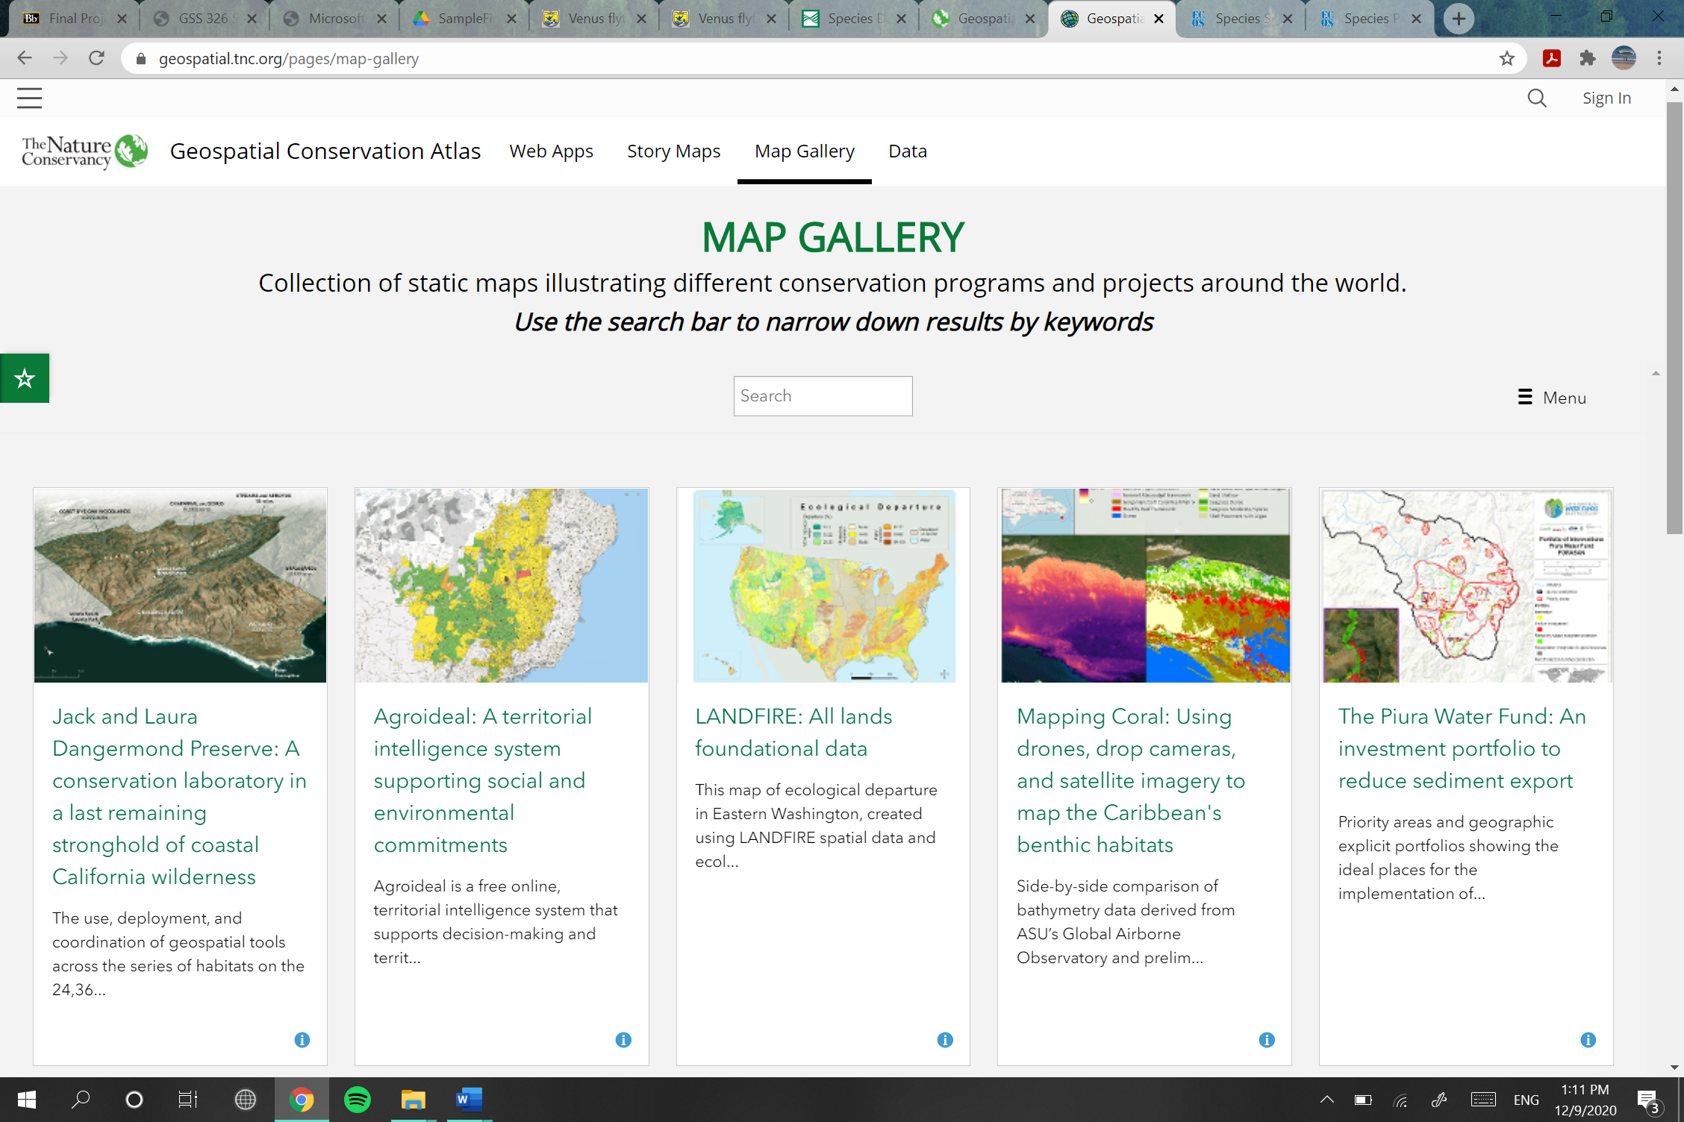

**Figure 1.** TNC Geospatial Conservation Atlas Map Gallery Structure

The map gallery of the surface water drainage patterns of Northeastern North Carolina will follow the structure of The Nature Conservancy’s holistic map gallery and serve as an accessible, interpretational tool of the oceanographic processes driving saltwater intrusion and sea level rise. The map gallery will be conveniently available within the horizontal bar at the top of the page of TNCNC’s website.

* + 1. **List Output Requirements**

|  |  |
| --- | --- |
| Homepage Title | Map Gallery |
| List Title | View Maps by Theme |
| Headings | Impervious surfaces, natural surfaces, sewage drain schematics, monthly precipitation, etc. |
| Typical Input | Maps related to a theme under a related tab |
| Source | Reports and data section of The Nature Conservancy in North Carolina |
| Interactive Map Title | Interactive map of the surface water drainage patterns in the study area |
| Text box contents | Site name, site properties, site manager, 3-8 bullet points conveying their research there and what it implies |
| Sources | TNCNC GIS Database |

* + 1. **Document Retrieval Requirements**

The document of the maps will be available in The Nature Conservancy in North Carolina’s website in a section files available to download for reference on Arc GIS Pro.

* 1. **Local and Invasive Species Populations**
     1. **Users**

The implementors of the data are staff members. This data will be public for any environmental scientists in need of organismal analysis. Appropriate citation necessary if the data is used outside of The Nature Conservancies’ faculty and staff.

* + 1. **Synopsis**

This feature will illustrate the unique organisms within the state of North Carolina. Vector data will be shown in levels of detail based on the scale of the map. A tab will be present on the main page of The Nature Conservancy in North Carolina’s home page. Field scientists will record the organisms and classify them by their biological taxonomy. This staff department will also determine if the organisms are endemic or not to the land they live on. All non-endemic species will be evaluated, via temporal maps, to see if they are invasive or not.

* + 1. **Map Output Requirements**

The map(s) must be able to process vast amounts of tabular data and demonstrate it in vector, point data across the study areas. To do this, tabular data may be recorded on tablets with the processing power, however, the datasets should be saved every 48 hours to an organization-deemed desktop.

* + 1. **List Output Requirements**

|  |  |
| --- | --- |
| Homepage Tab Title | ‘What’s Living in NC?’ |
| List Title | View Species by Order |
| Headings | Animalia, Plantae, Fungi, etc. |
| Typical Input | Vector data demonstrating preferred habitats |
| Source | Reports and data section of The Nature Conservancy in North Carolina |
| Sources | TNCNC GIS Database |

* + 1. **Document Retrieval Requirements**

The documents and data of the maps will be available in The Nature Conservancy in North Carolina’s website in a section files available to download for reference on Arc GIS Pro. TNC staff and clientele will have unlimited access to this data for educational or organizational benefit.

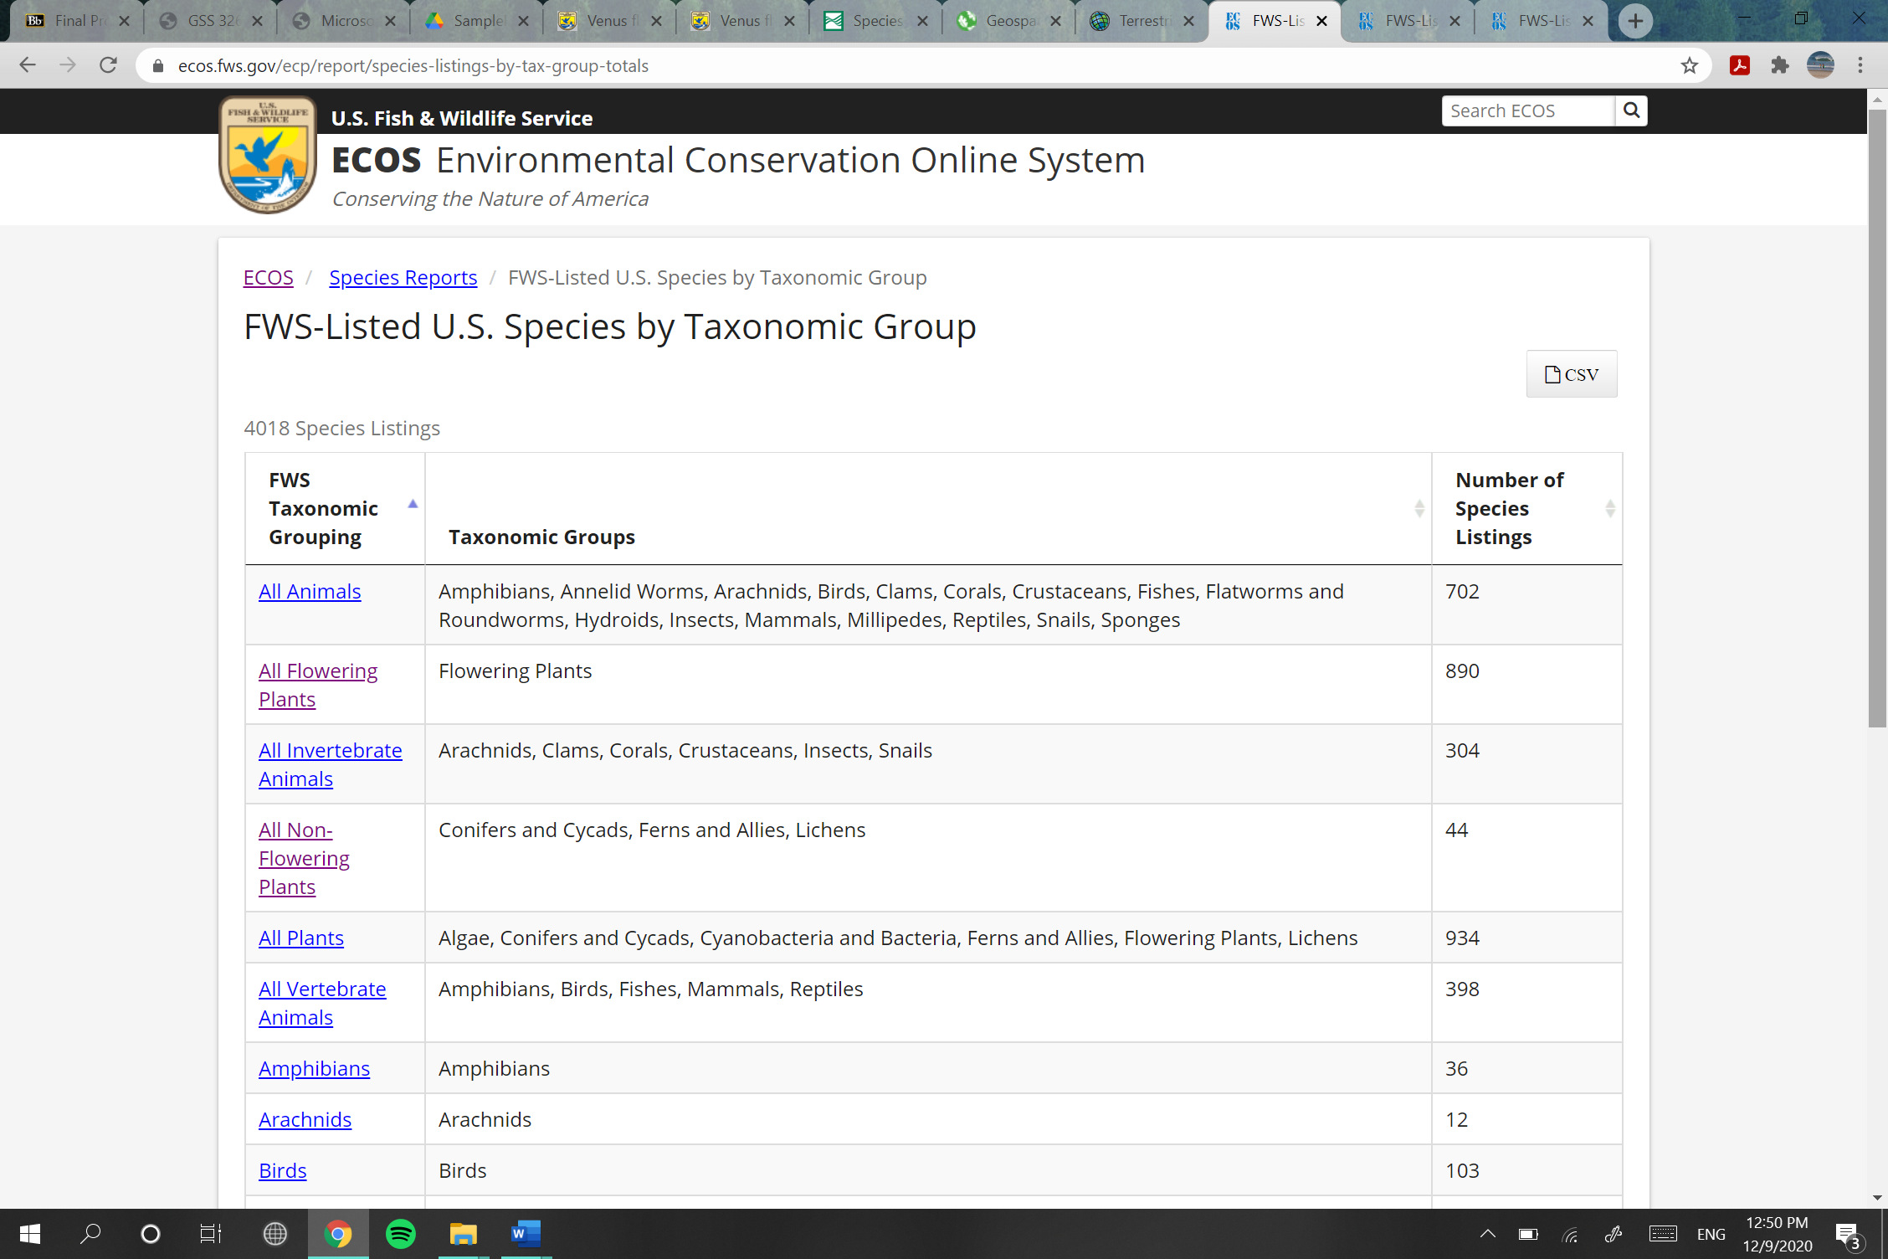

**Figure 2.** U.S. Fish & Wildlife Service ECOS Species Reports Tabular Structure

The map gallery organizational strategy will be modeled after the admirable U.S. Fish & Wildlife Services Environmental Conservation Online System (ECOS) website. The Nature Conservancy’s logo will be placed along the top left of the site, like the representational image. The taxonomic hierarchy structure will be analogous to the ECOS website in the sense that it will start from the broadest taxa and then funnel down into the species ranking based on the amount of tab clicks.

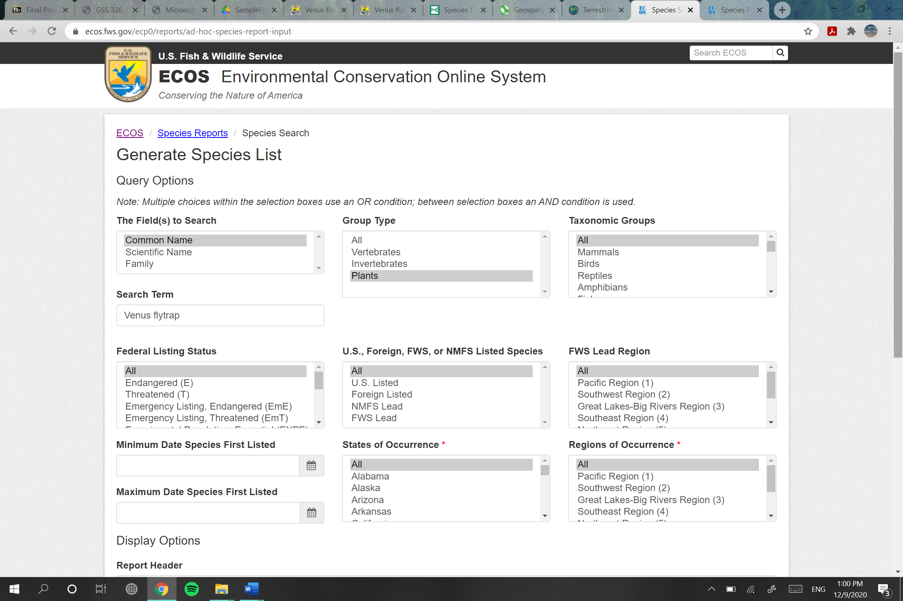

**Figure 3.** U.S. Fish & Wildlife Service ECOS Species Reports Search Engine

1. **Functional Requirements**

This section depicts a chronological overview of how to create the information products. Included below are the data and functions necessary to create them.

* 1. **Maps of Surface Water Drainage Patterns**

|  |  |
| --- | --- |
| **Data Source** | **Steps to Make Product** |
| * Reports and Data section of TNCNS’s website * TNCNC’s GIS Database | * Review all published maps from the Reports and Data section of the website * Remove the current maps * Create a bulleted list of map themes * Assign all maps a theme and some key words * Add maps to the geodatabase with assigned key words for easy reference * Provide links to the maps on the Map Gallery page of the website * Develop a search engine for the maps using ArcGIS Engine. * Create the interactive map using ArcGIS online. * Create a map of North Carolina * Delineate area(s) of concern * Add feature layers that depict the specific natural process(es) * Add text box and necessary map elements * Ensure it is under the organization with the TNC globe logo |

* 1. **Local and Invasive Species Populations**

|  |  |
| --- | --- |
| **Data Source** | **Steps to Make Product** |
| * Reports and Data section of TNCNS’s website * TNCNC’s GIS Database | * Field work assessing organisms in TNC Protected Areas * Transfer on-the-field data into the enterprise GIS * Create aesthetically pleasing tabular data for the staff * Make datasets easily accessible across departments * Review all published maps from the Reports and Data section of the website * Add maps to the geodatabase with assigned key words for easy reference * Delineate area(s) of concern * Add feature layers in taxonomical order * Add text box and necessary map elements * Ensure it is under the organization with the TNC globe logo |

1. **Data Sources and Data Acquisition**

This section talks about the necessary data and how it will be acquired. Furthermore, it will demonstrate where the needed data will be appropriately acquired from. It covers data identification, volume considerations, characteristics, and cost.

* 1. **Map Gallery of Surface Water Drainage Patterns**

|  |  |  |
| --- | --- | --- |
| **Component** | **Details Needed** | **Notes** |
| *Data Identification* | Dataset name  Dataset number  Dataset agency name  Metadata available | Map Gallery of Surface Water Drainage Patterns  N/A  The Nature Conservancy in North Carolina  Yes |
| *Data Volume Considerations* | Source data medium  Digital data format  Percentage available now in digital format  Primary record type  Primary record volume  Total data volume | PDF or ArcPro feature layer, taken from the Reports and Data section of TNCNC’s website  Jpg. or ArcPro feature layer  80%  Jpg.  Unknown  Unknown |
| *Data Characteristics* | Data type  File format  Map projection  Dynamic or Static | Report or dataset  Jpg. or feature layer  N/A  Static |
| *Data Characteristics* | Percent Coverage Available | 100% (data is owned by the client organization) |

* 1. **Local and Invasive Species Populations**

|  |  |  |
| --- | --- | --- |
| **Components** | **Details Needed** | **Notes** |
| *Data Identification* | Dataset name  Dataset number  Data agency name  Metadata available | Interactive Maps of Local and Invasive Species in North Carolina  N/A  The Nature Conservancy in North Carolina  Yes |
| *Data Volume Considerations* | Source data medium  Digital data format  Percent available now in digital format  Primary record type  Primary record volume  Total data volume | PDF or ArcPro feature layer, taken from the Reports and Data section of TNCNC’s website  CSV, PDF, or shapefile  71%  CSV, PDF, or shapefile  Unknown  Unknown |
| *Data Characteristics* | Data type  File format  Map projection(s)  Dynamic or static | Report or dataset  CSV or shapefile  Unknown  Dynamic |

1. **Workflow Diagrams**

This section supplies the reader with diagrams depicting the meticulous processes behind creating the information products. Circles within the diagrams represent a function or operation. Rectangles represent palpable data.

* 1. **Basemap for Analyzing Surface Water Drainage Patterns**

This Basemap will provide The Nature Conservancy the appropriate topological data to implement research in mapping the surface water drainage patterns of Northeastern North Carolina. Assessing the gravity of the drainage patterns across the study area(s) will illustrate which areas are most adversely affected by saltwater intrusion.

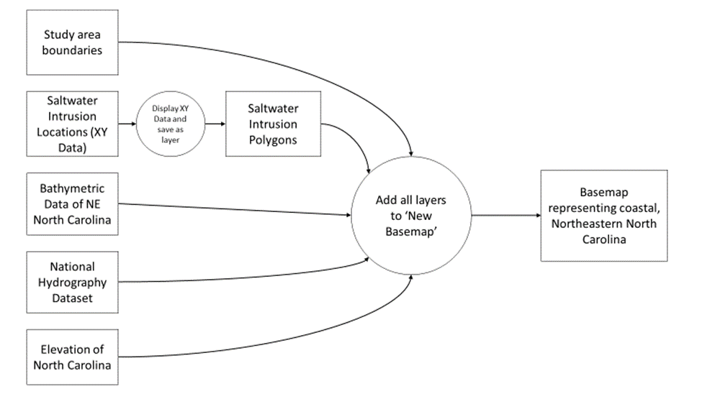

* 1. **Local and Invasive Species Populations**

This data collection workflow will provide The Nature Conservancy in North Carolina with precise population data of the endemic and, potentially, invasive organisms within the organizations conserved areas.

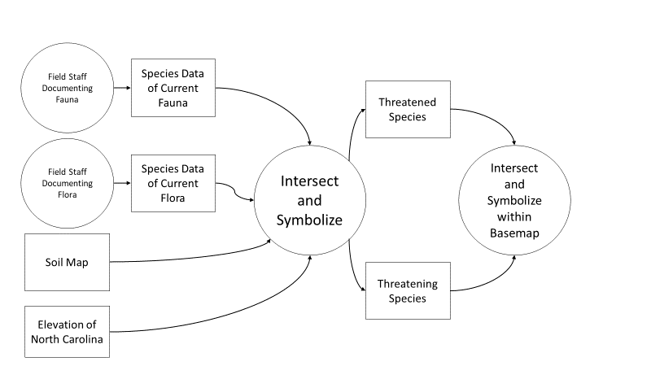

**8. Selected Information Products and Discussion of Results**

This section discusses the results from the creation of prototype information products. It demonstrates the outputs of the project and depicts the potential longevity of the future of these information products.

**8.1 Map Gallery of Surface Water Drainage Patterns**

Due to the immense temporal datasets necessary to streamline a map gallery of surface water drainage patterns, I included a Gantt chart to illustrate the time stamps on each information product. The GIS manager must keep a steady eye on this chart to ensure that each department is producing their assigned work on time.

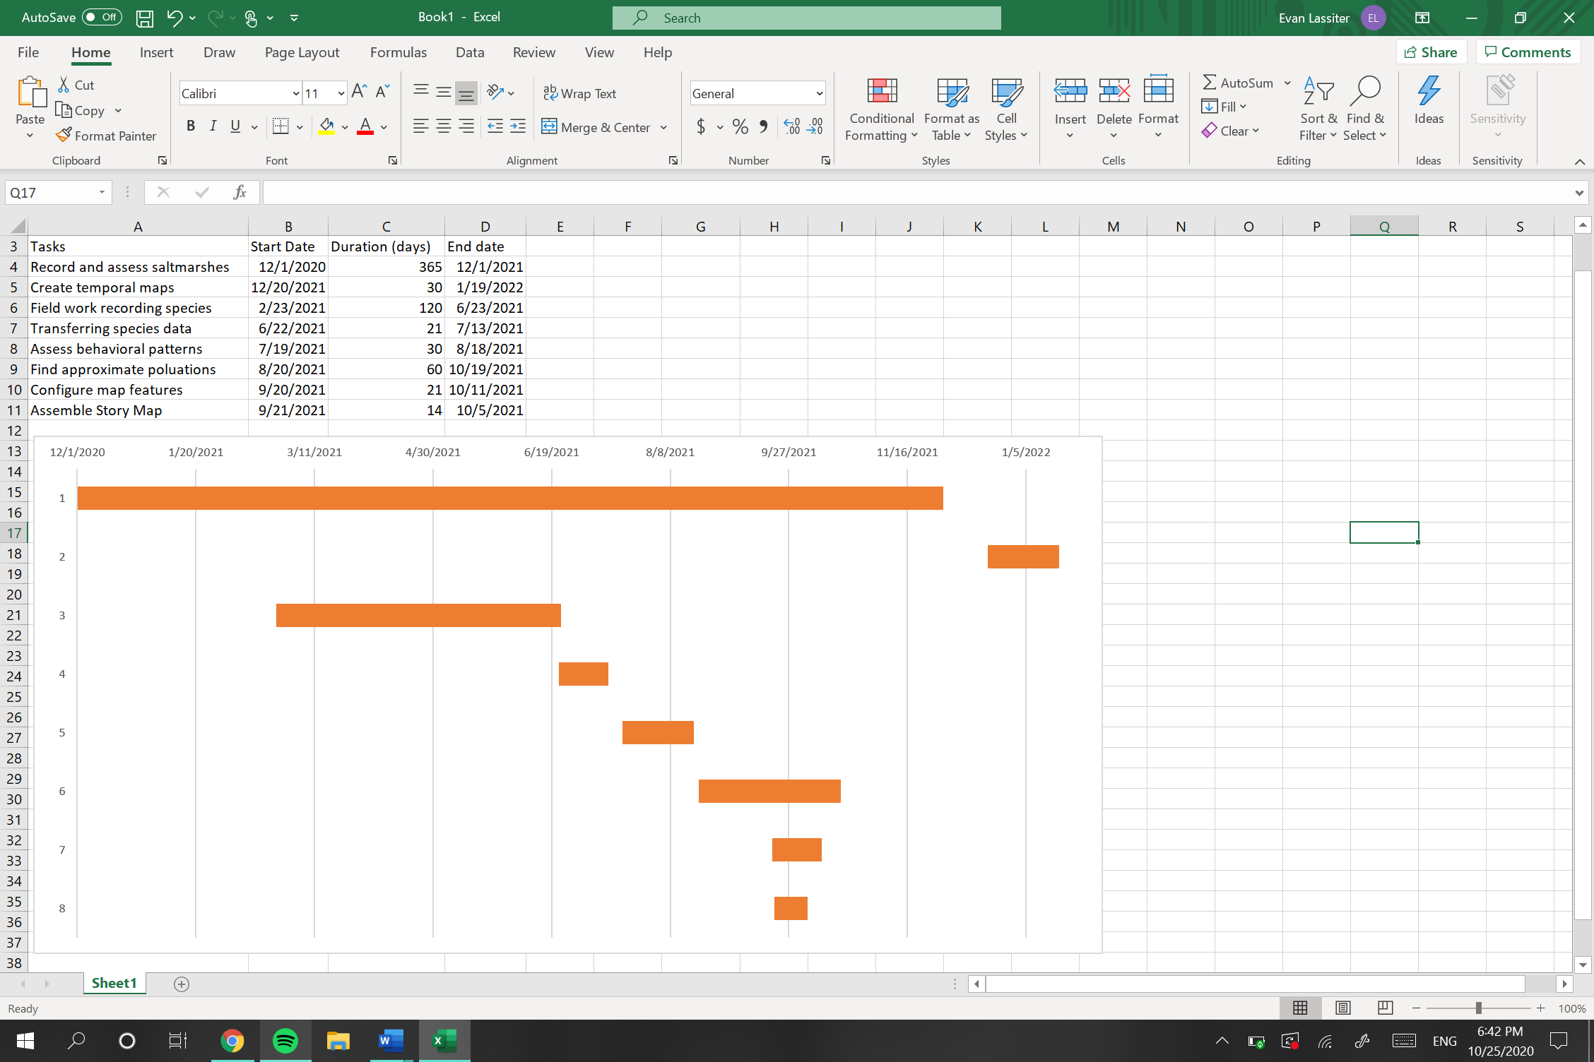

**Figure 4.** Gantt Chart for Project Proposal

Each attribute will be separately represented within their own tab; however, a holistic mapping of the surface water drainage patterns will be available by aggregating all the feature layers together in a geodatabase. For instance, the ArcGIS image below will be one tab within the map gallery, representing the elevation of the land in the area.

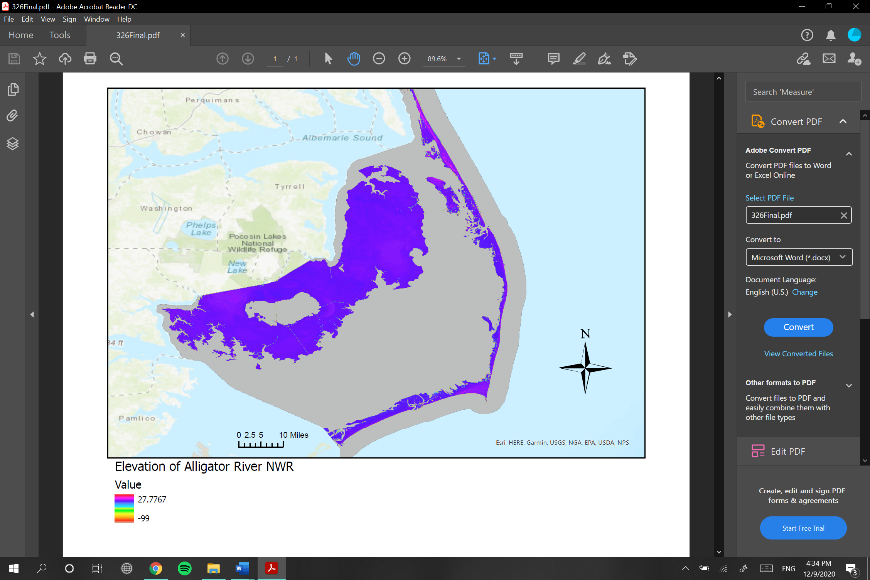

**Figure 5.** Digital Elevation Model for Map Gallery

**8.2 Local and Invasive Species Populations**

To validate the importance of an interactive species population map within North Carolina, I created conceptual images dissecting the processes behind the product’s output. The species chosen for the demonstration is the Venus flytrap (*Dionaea muscipula*) because of its recently arbitrary population status. Venus flytraps are highly vulnerable to population decline predominately because of their compact habitat range, which spans a 75-mile radius around the town of Wilmington, North Carolina. Some other prominent factors to Venus flytrap population decline include over-collection, bedding, clearcutting, and road expansion. Therefore, representing highly concentrated species via interactive vector data will serve as a strong basis for further analysis of which environmental stressors are most adversely impactful.

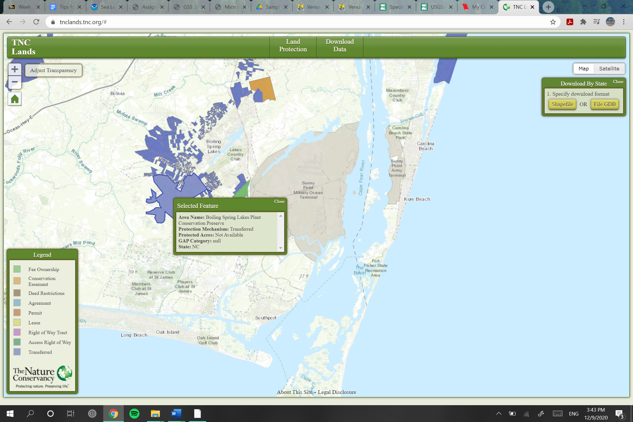

**Figure 6.** Delineated TNC Land Area of Focus

The interactive portion of species vector data should be modeled in a way like the mobile application iNaturalist. This allows the public to enjoy what is around them and gives them a sense of responsibility for protecting their immediate environment. The data in the images below demonstrates that land preserved by TNC possessed exponentially more Venus flytraps than the land surrounding the Boiling Spring Lakes Plant Conservation Reserve. However, the app does not provide taxonomic breakdowns along with the sightings.

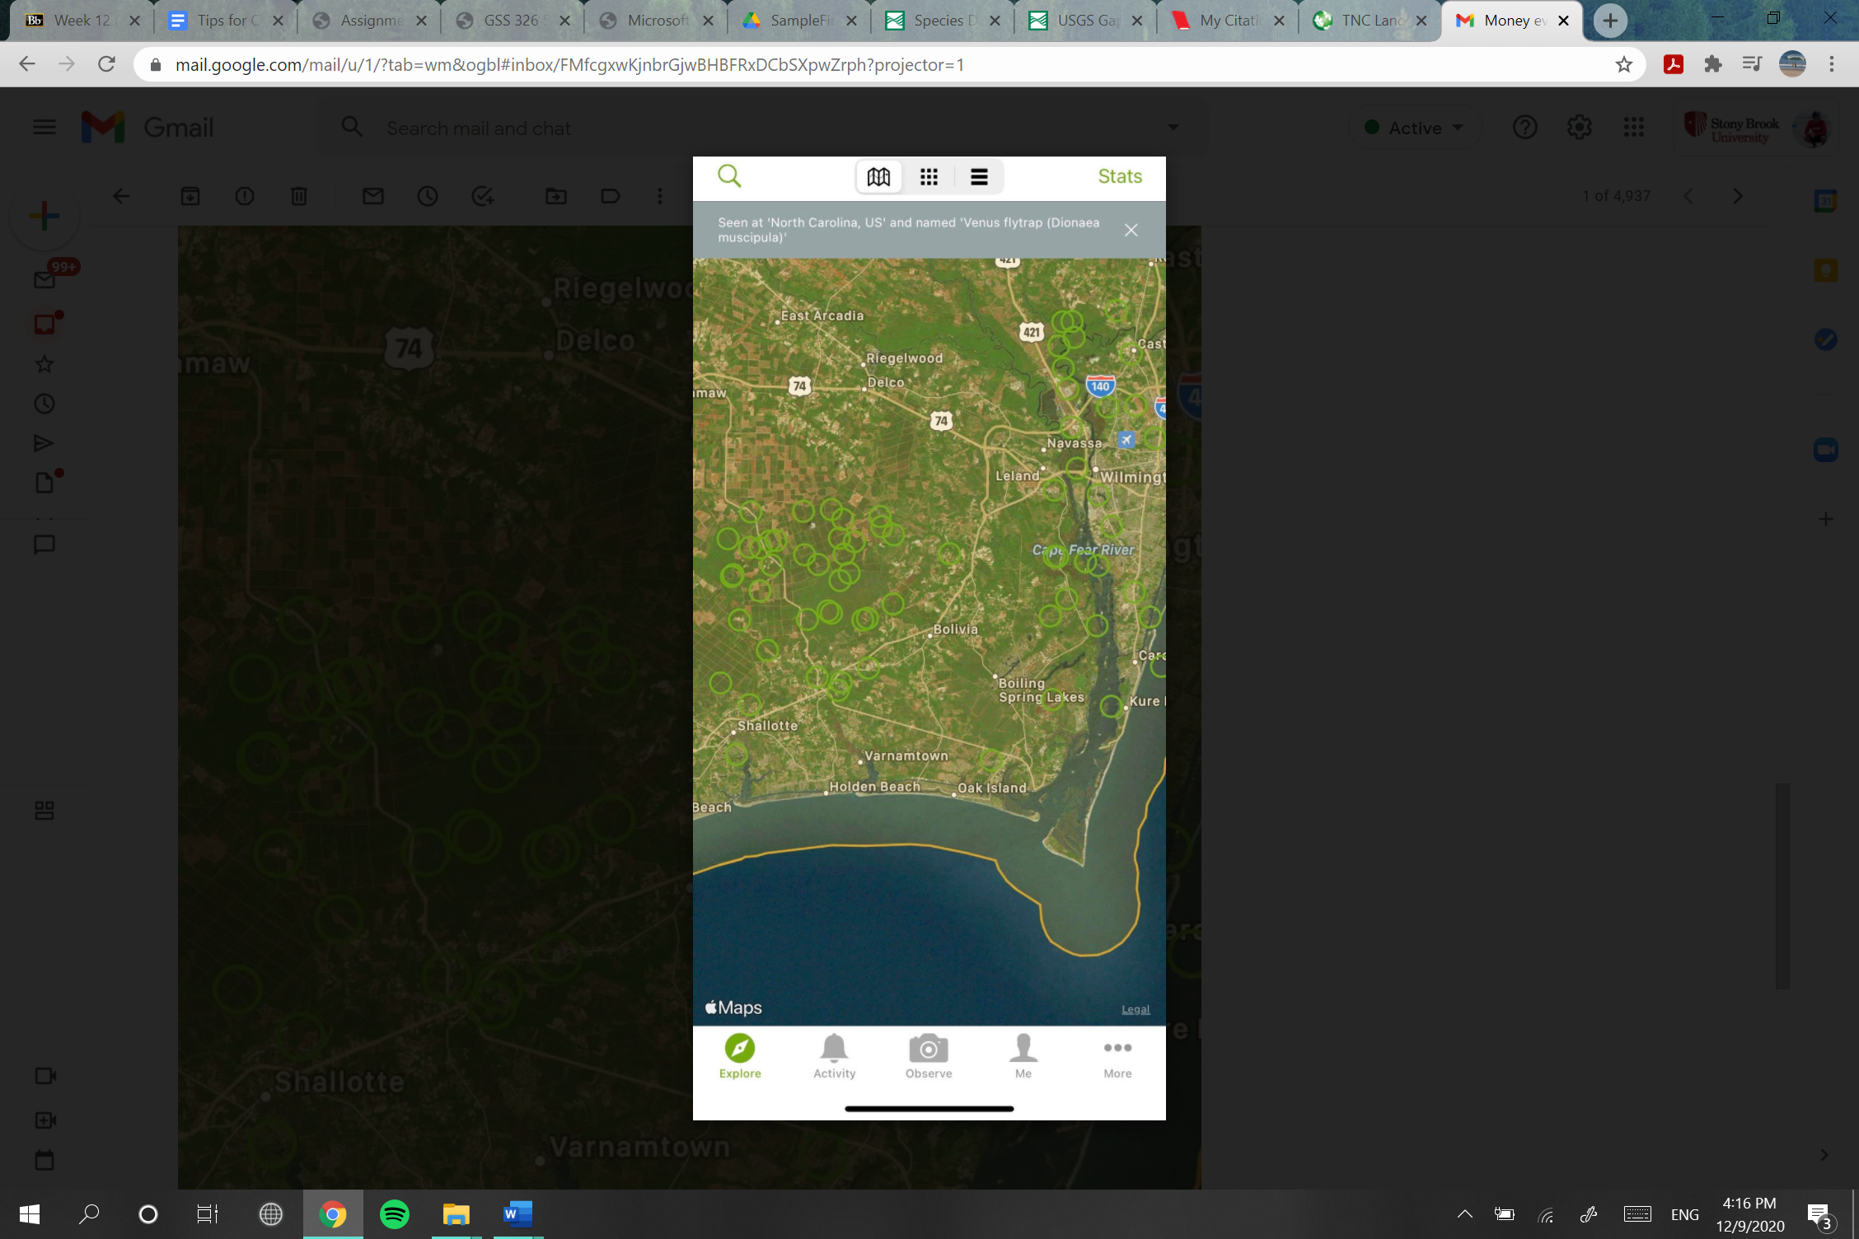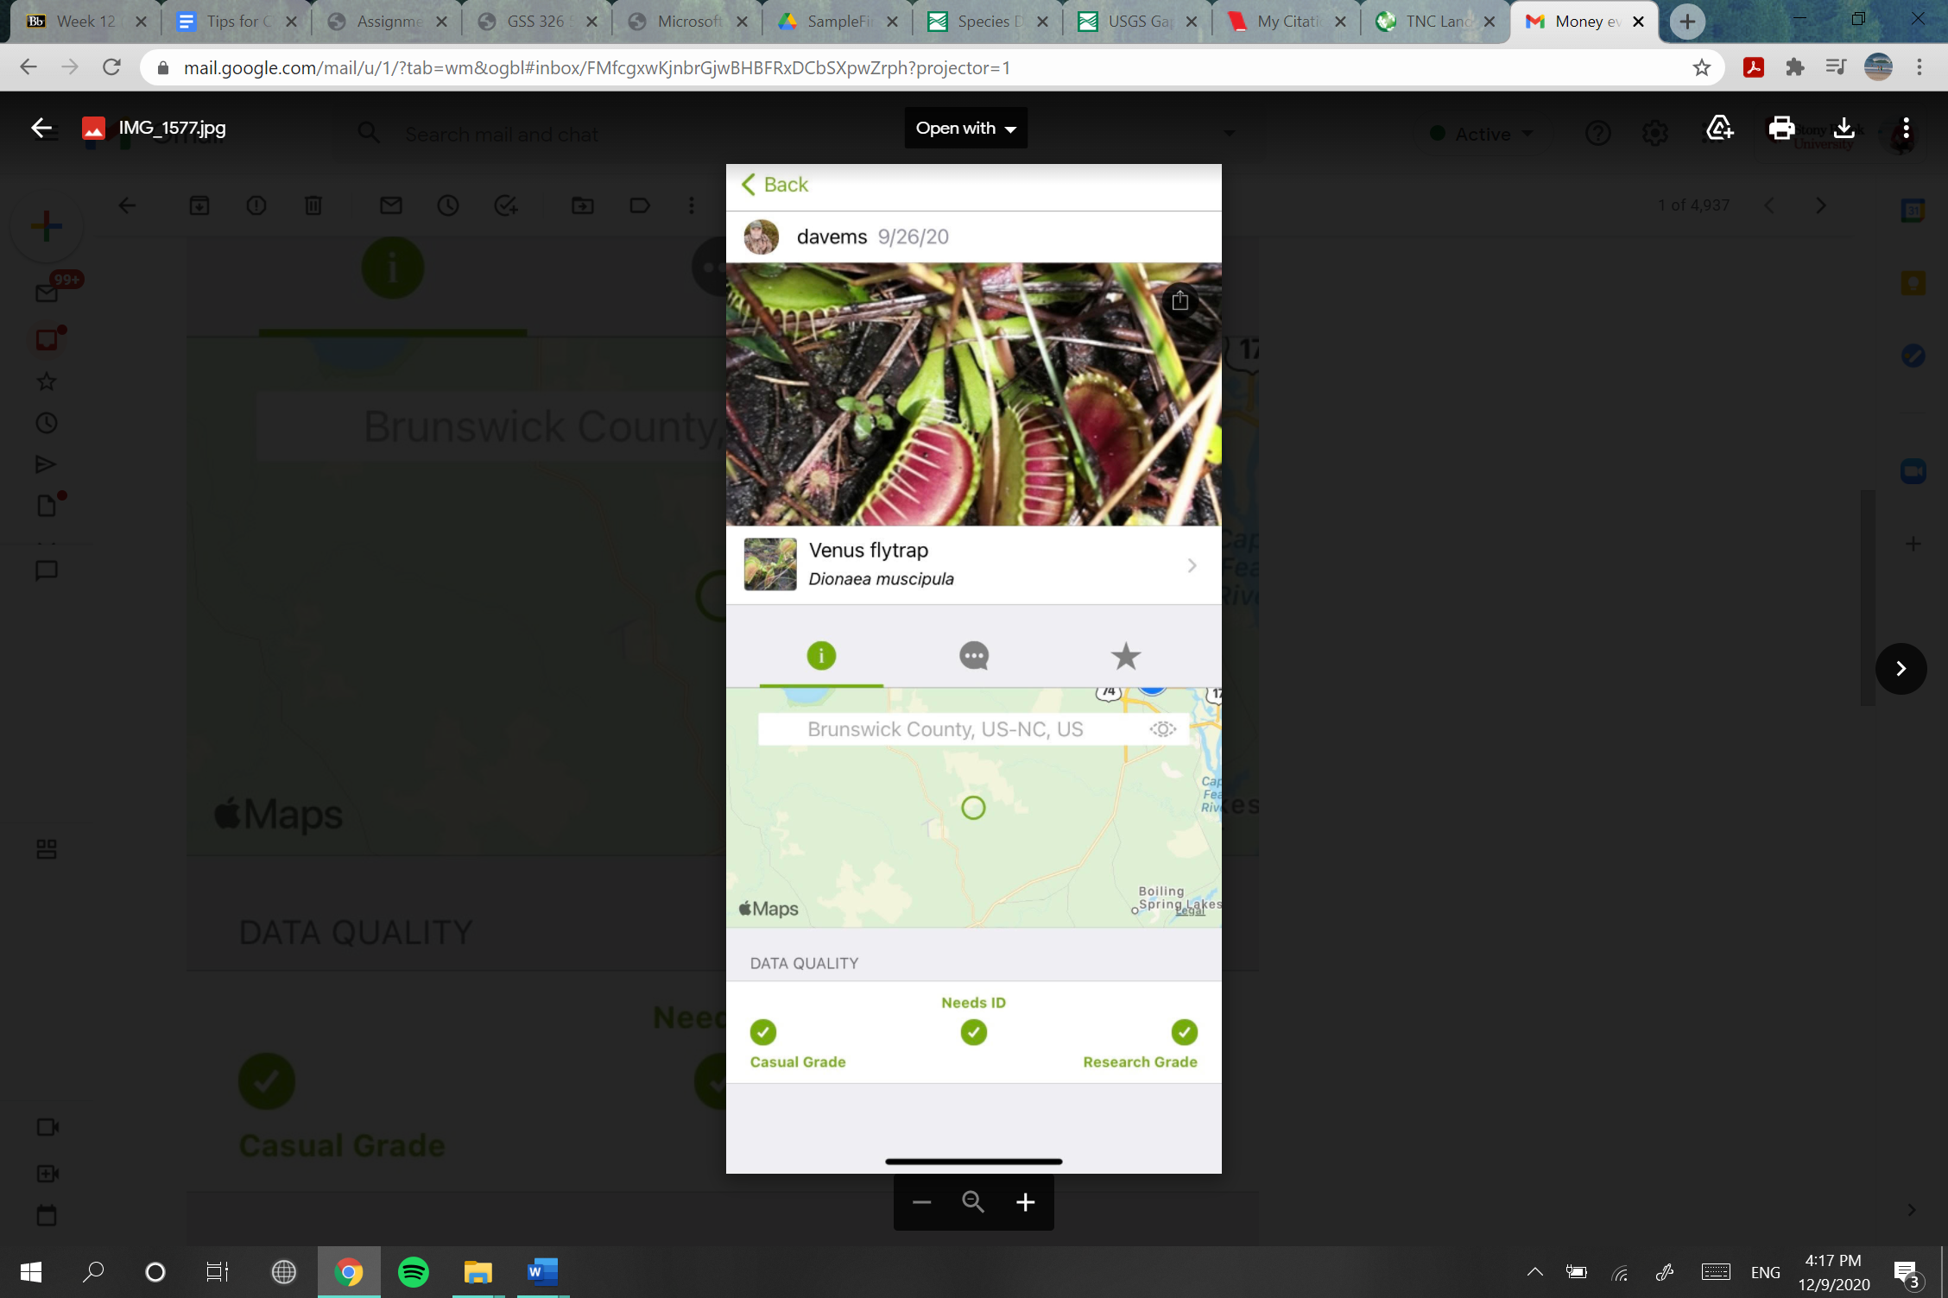

**Figure 7. INaturalist Venus Flytrap Sightings**

**9. Summary, Conclusions, and Recommendations**

This segment serves as a review of what was accomplished effectively in the project, what was adequate, and what could be improved. It will also discuss the conclusions to be taken from an overview of this project proposal, as well as recommendations for people working in similar areas of study.

This project focuses on improving or updating the versatility of TNCNCs GIS system and website. Our overall mission is to conserve our lands and water as best as we can to support the life that depends upon it. This daunting mission statement would not be in place without the adept and widely varying roles TNC staff occupy. The need for accurate and precise spatial data is a reoccurring demand for all interdepartmental staff within The Nature Conservancy. Streamlining complex oceanographic processes, such as surface water drainage patterns, to an attractive online map gallery will increase staff and clientele efficiency and will prove beneficial by producing accurate data to increase the longevity of the coastlines of North Carolina.

Creating an interactive online environment using data regarding species of concern will exponentially increase the popularity of The Nature Conservancy because it could be exploited as an extremely accessible educational tool available to teachers for them to show students, perhaps before going on a field trip to excite the already eager class. Furthermore, it will create a baseline insight into the current population trends of a certain species, spatially. This in turn will serve as a feasible and fun stepping-stone into the realm of preventing extinctions.

To demonstrate the feasibility of the information products repetitively stated throughout the report, prototypes, pictures, and maps were utilized to demonstrate functionality. Furthermore, pictures were spread throughout the project document for visual representation of the potential website aesthetics.

After reviewing the results of the maps and images, I would highly recommend looking into accessible vector data that can be efficiently downloaded for quick representation in a map. Downloadable Venus flytrap data was very difficult to come by on laptop. Therefore, INaturalist was used as a representation for the interactive portion of the information product. The feasibility behind the search engine for the interactive species search should also be carefully analyzed.

**10. References**

“Accountability at The Nature Conservancy.” *The Nature Conservancy*, [www.nature.org/en-us/about-us/who-we-are/accountability/](http://www.nature.org/en-us/about-us/who-we-are/accountability/).

“Conservancy Launches Climate Change Adaptation Project.” Edited by Debbie Crane, *North Carolina - The Nature Conservancy*, The North Carolina Chapter of The Nature Conservancy, 2009, [www.nature.org/media/northcarolina/afield_spring09_proof2.pdf](http://www.nature.org/media/northcarolina/afield_spring09_proof2.pdf).

“FWS-Listed U.S. Species by Taxonomic Group.” *ECOS*, U.S. Fish and Wildlife Service, ecos.fws.gov/ecp/report/species-listings-by-tax-group-totals.

*Geospatial Conservation Atlas*, The North Carolina Chapter of The Nature Conservancy, geospatial.tnc.org/pages/map-gallery.

“INaturalist User Guide.” *INaturalist*, 12 Apr. 2017, [www.inaturalist.org/posts/9394-inaturalist-user-guide](http://www.inaturalist.org/posts/9394-inaturalist-user-guide).

Love, Shayla. “A Poacher Who Stole 970 Venus Flytraps in N.C. Is Sentenced to Prison.” *The Washington Post*, WP Company, 28 July 2016, [www.washingtonpost.com/news/morning-mix/wp/2016/07/28/a-poacher-who-stole-970-venus-flytraps-in-n-c-is-sentenced-to-prison/](http://www.washingtonpost.com/news/morning-mix/wp/2016/07/28/a-poacher-who-stole-970-venus-flytraps-in-n-c-is-sentenced-to-prison/).

“Places We Protect.” *The Nature Conservancy*, [www.nature.org/en-us/get-involved/how-to-help/places-we-protect/](http://www.nature.org/en-us/get-involved/how-to-help/places-we-protect/).

Service, U.S. Fish and Wildlife. *Species Search*, ecos.fws.gov/ecp0/reports/ad-hoc-species-report-input.

Title Image: <https://www.google.com/url?sa=i&url=https%3A%2F%2Fwww.facebook.com%2FTNCNC%2F&psig=AOvVaw3-zuSRxArRalcQrad4Puzc&ust=1604001214214000&source=images&cd=vfe&ved=0CAIQjRxqFwoTCIDpqaeI2OwCFQAAAAAdAAAAABAJ>

“Venus Flytrap.” *U.S. Fish & Wildlife Service*, 28 May 2020, [www.fws.gov/southeast/wildlife/plants/venus-flytrap/](http://www.fws.gov/southeast/wildlife/plants/venus-flytrap/).

“Who We Are.” *The Nature Conservancy*, [www.nature.org/en-us/about-us/who-we-are/](http://www.nature.org/en-us/about-us/who-we-are/).

**11. Appendices**

**Appendix B**

Abbreviations

GIS: Geospatial Imaging System

TNC: The Nature Conservancy

TNCNC: The Nature Conservancy in North Carolina

ECOS: Environmental Conservation Online System

NWR: National Wildlife Reserve